Rational

politics?

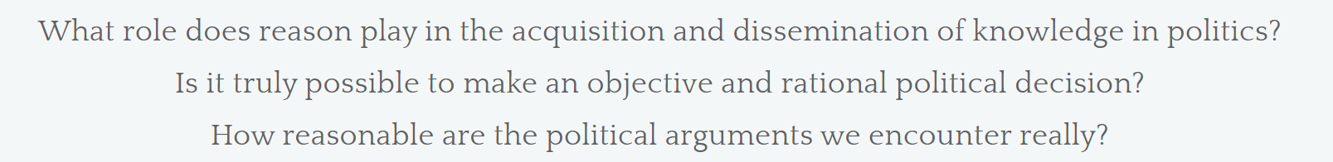

Key concepts:

- Bias:……………..…………………………………………………………………………………………………………………..
- Partisanship:..……………………………………………………………………………………………………………………
- Partisan news:...................................................................................................................................
- Social media bubbles:..………………………………………………………………………………………………………
- Filter bubbles:……………………………………………………………………………………………………………………
- Echo chambers:…………………………………………………………………………………………………………………
- Logical fallacies/informal reasoning:..…………………………………………………………………………………
………………………………………………………………………………………………………………………………………….
………………………………………………………………………………………………………………………………………….
- Political identity:…………………………….………………………………………………………………………………….
- Group identity (and sense of self):..…………………………………………………………………………………….
- Political beliefs:………..………………………………………………………………………………………………………..
- Cognitive dissonance:…………………………………………………………………………………………………………
- (Revision of) facts:……………………………………………………………………………………………………………..
- (Rejection of) evidence:……………………………………………………………………………………………………..
- Polarisation:………………………………………………………………………………………………………………………
- Policies (whether or not grounded in truth or reason):………………………………………………………….
…………………………………………………………………………………………………………………………………………
- Evidence-based decisions:…………………………………………………………………………………………………

Warm-up (think-pair-share)
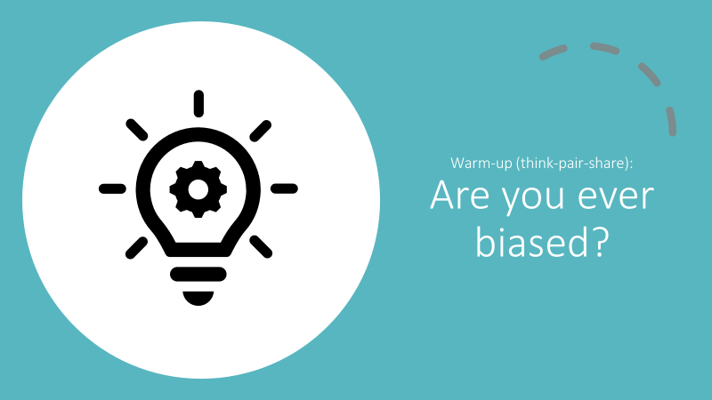
What could you do to avoid this bias?

What shapes my political identity?
Brainstorm any ideas or factors you can think of.
TIP: Ask a friend whether you might have missed out a factor that you were previously unaware of.

Research and exhibition practice
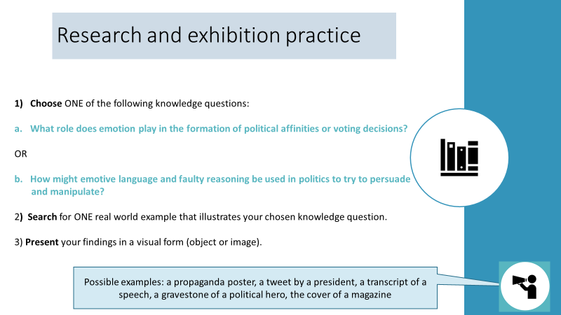
My image/object:

Logical fallacies:

Link the name of the fallacies with their short definition.

- Post hoc ergo propter hoc a. Using double standards to excuse an individual or group.
- Argument ad hominem b. Assuming the truth of what you are supposed to prove.
- Special pleading c. A question with a built-in assumption.
- Circular reasoning d. Using language ambiguously in an argument.
- Argument ad ignorantiam e. Assuming that only two black and white alternatives exist.
- False analogy f. It happened after, so it must be caused by.
- Loaded question g. Attacking the arguer, not the argument.
- Argument ad populum h. assuming a logical link between two separate points
- Non sequitur i. assuming the majority gets it right
- Straw man j. caricaturing a position to make it easier to attach
- Equivocation k. Assuming that things are alike in all respects because they
are alike in some respects
- False dilemma l. Claiming something is true because you cannot prove it is
false.

1 | 2 | 3 | 4 | 5 | 6 | 7 | 8 | 9 | 10 | 11 | 12

Match the following fallacies with their name (1-12, see above).
1. Strict gun control laws were introduced in Texas, the crime rate has risen. This shows that gun control does nothing to reduce crime. [ ]
2. In the fight against terrorism, you are with us or against us. [ ]
3. You are a woman, your argument couldn’t possibly be true. [ ]
4. Do you always cheat in exams? [ ]
5. How can you convict this man of patricide? He’s an orphan! [ ]
6. Barak Obama was just like Hitler because they were both socialists. [ ]
7. The Bible is the word of God because the Bible says so, and it is written by God. [ ]
8. Ghosts exist because you can’t prove that they not not exist. [ ]
9. A burger is better than nothing. Nothing is better than good health. So a burger is better than good health. [ ]
10. In my google search, this spelling comes up as the most popular, so it must be correct. [ ]
11. Men are human. Mary is human. Therefore, Mary is a man. [ ]
12. A: Sunny days are good. B: If all days were sunny, we'd never have rain, and without rain, we'd have famine and death. [ ]

