POst-truth

politics

Key concepts:

- (Alternative) facts…………………………………………………………………………………………………………….
- Post-truth politics………………………………………………………………………………………………………………
………………………………………………………………………………………………………………………………………….
- Correspondence theory of truth…………………………………………………………………………………………..
………………………………………………………………………………………………………………………………………….
- Coherence theory of truth…………………………………………………………………………………………………..
………………………………………………………………………………………………………………………………………….
- Pragmatic theory of truth……………………………………………………………………………………………………
- Dogma………………………………………………………………………………………………………………………………

What if…?
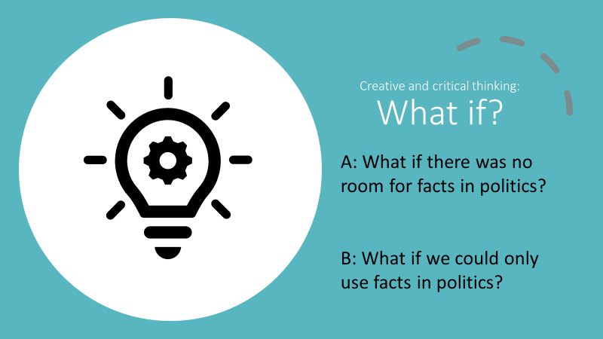
What did you take away from this task?

What is truth?
Which words do you think of, when we say “truth”? (brainstorm)

Can you use some of these words to make a definition for the concept “truth”?
Truth is………………………………………………………………………………………………………………………………….

Plenary reflection
    - In what ways is factual evidence sometimes used, abused, dismissed and ignored in politics?
    - Is it ever justifiable for a politician to act without having good grounds or evidence for doing so?
    - Given access to the same facts, how is it possible that there can be disagreement between experts on a political issue?
    - Why do facts sometimes not change our minds?

