Appendix: passages from 1984 Taken from https://archive.org/details/1984pdf_202003/mode/2up
Cut these out and share amongst students
--------------------------------------------------------------------------------------------------------------------------------------

A 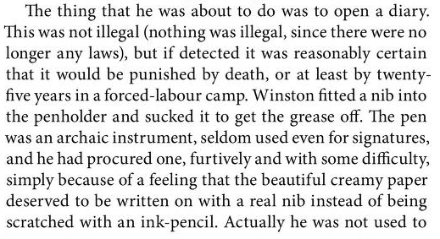

--------------------------------------------------------------------------------------------------------------------------------------

B 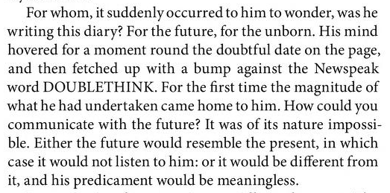

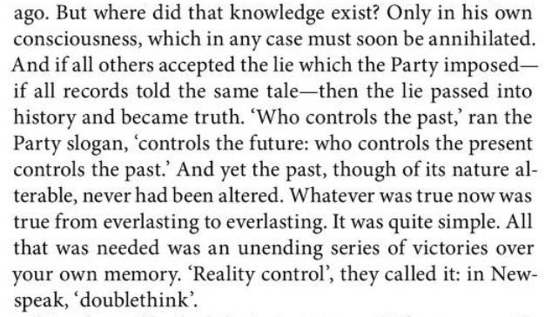
C
--------------------------------------------------------------------------------------------------------------------------------------

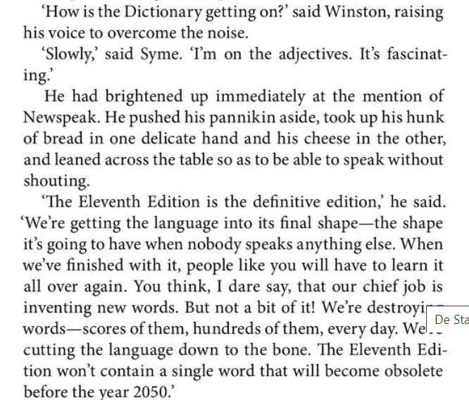
D

E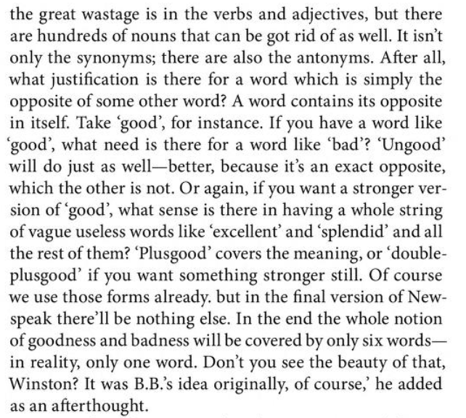

--------------------------------------------------------------------------------------------------------------------------------------

F 