Language

And power

Key concepts:

- Dominant discourse…………………………………………………………………………………………………………
- Nuance:…………………………………………………………………………………………………………………………..
- Cognitive dissonance:……………………………………………………………………………………………………….
- Orwellian:…………………………………………………………………………………………………………………………

Thought experiment…
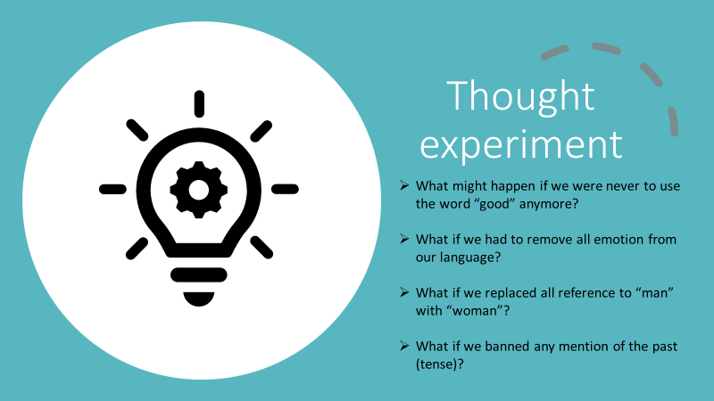
Think-pair-write-share:

Role-play task reflection:
What challenges did you face when completing the role-play task?
What might this suggest in terms of the ability of language to control our thought?

Language and power: an analysis of passages from 1984 (see appendix)
What does your chosen passage suggest regarding the relationship between language, power and thought?

Orwellian manifestations in the world around us?
Can you find examples from the real world where language is used to control, shape, manipulate or even censor thought?

Exhibition practice: find one object that illustrates the relationship between language and power.
My chosen object: | Guiding phrases for the mini-museum activity
Paste the image of your object here: | -This object shows…  -The real-world context is….  -I have chosen this object because….  -This object is significant because….  -This object illustrates the relationship between language and power because….  -This object evokes the following TOK concept(s):  -To support my claims, we can look at the following evidence….

