Language as a map 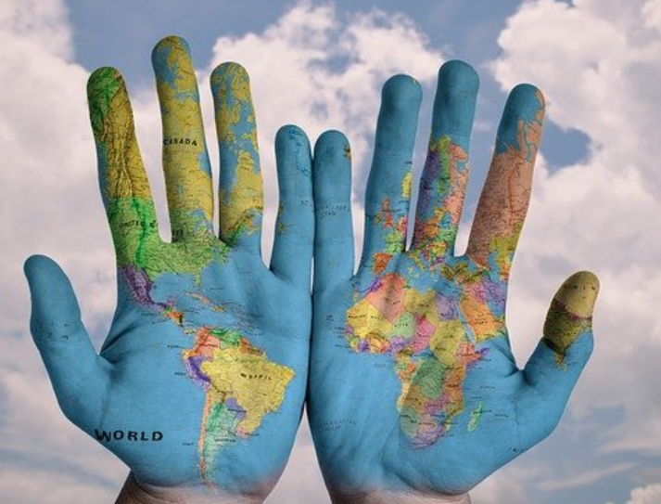

Draw the following…

Breakfast Cat Man

Woman Love Hope

God Truth Collateral damage-killing innocent people

From knowledge as a map to language as a map…
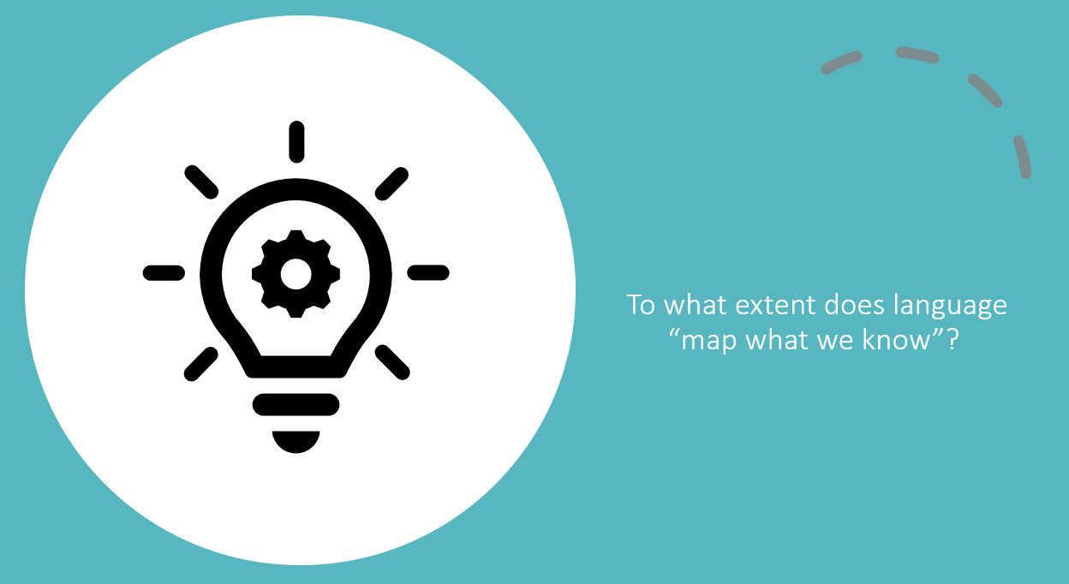
Think-pair-write-share:

The language of an AOK:
Research and explore the nature, role, purpose of language within your allocated AOK.
Summarise your main findings here:

Reflection (homework):
- Can all knowledge be expressed in words or symbols?
- Is it possible to think or know without language?
- To what extent is it possible, or desirable, to overcome ambiguity in language?

Key concepts:
- Signifier/signified:………………………………………………………………………………………………………………………………………………………………………………………………………………………………………………………….
- Denotation/connotation:…………………………………………………………………………………………………….………………………………………………………………………………………………………………………………………….
- Words and symbols to express knowledge:………………………………………………………………………….
………………………………………………………………………………………………………………………………………….

