Unit plan: Knowledge and language  What?  In this unit, students learn about knowledge and language. The lessons place a particular emphasis on the strengths and pitfalls of language to map and communicate what we know, the connection between culture and language, as well as language and power.  Why?  A deeper understanding of both the strengths and shortcomings of language in the context of knowledge acquisition and production will foster critical thinking when faced with real-world manifestations of things such as dominant discourse, linguistic imperialism, thinking through signs, ambiguous language, and the particular language used by an AOK.  How?  Through a blend of inquiry based, creative activities, students are led to the exploration of TOK concepts and knowledge questions. | KEY terms: Signifier/signified, culture, knowledge as a map metaphor, artificial languages, idioms, euphemism, dominant discourse.  ATL: Learner profile/ internationalism Thinking skills (creativity) Collaboration Communication Thinkers, reflective Dominant discourse and linguistic imperialism. The connection between language and culture.  CONNECTIONS: Knowledge and the knower (core theme), group 1-2 subjects, knowledge and politics (option).
TOK concepts |  | Assessment link
Interpretation, power, culture. |  | Exhibition practice: finding objects on “language and power” (lesson 3).
Lesson 1 | Lesson 2 | lesson 3
Language to map what we know | Language and culture | Language and power
Main ideas | Main ideas | Main ideas
Signifier-signified, Language, words and symbols to map knowledge, Connotation-denotation | Relationship language-culture, what do we want/need from a language? | Dominant discourse, censorship, language-cognition,  Persuasive language, linguistic imperialism
linked resources | linked resources | linked resources
Powerpoint 1, Student handout 1.  Crash course video: Language and meaning. | Powerpoint 2, Printable agree continuum.  TED ed about artificial languages. Video about the Dothraki language. | Powerpoint 3, Student handout 3, Appendix 1984, Language glossary.  TED ed: What Orwellian really means.
Lesson progression and suggested activities
Lesson 1: Language to map what we know (lesson 1_language_map_ppt and lesson 1_language_map_handout).

- Warm-up activity: Discussion question “Ceci n’est pas une pipe” (see Language_map_lesson 1_Ppt.):
What might Magritte have meant with his painting below, accompanied by the words “Ceci n’est pas une pipe?”[this is not a pipe].
(teachers, read more here).

Image taken from Wikiart.org

- Drawing task: language and symbols (lesson 1_language_map_ppt and lesson 1_language_map_handout).

- Ask students to draw the following: Cat, breakfast, love, woman/man, God, hope, collateral damage.
Compare the drawings of different students and unpack possible similarities and/or differences. Students from South-East Asian origins may draw a very different symbol for “breakfast” compared with their European peers, for example, yet the word “breakfast” is the same. Use this as a hook to explore the difference between signifier (sound or image) and signified (concept). Explore whether abstract concepts were more difficult to draw (use symbols for) or not, then link to the difficulties (and possibilities) of using language to map such abstract ideas. Use “collateral damage” to explain the difference between denotation/connotation (eg compare with “killing of innocent people”). Use “man” and “woman” to explain the danger of thinking through signs and words rather than “what is actually out there.” (teachers, read more here).
- Then watch this video lesson as a whole class.

- Language as a map. (link with core theme and the knowledge as a map metaphor from the TOK guide).
(lesson 1_language_map_ppt and lesson 1_language_map_handout).
Revisit the knowledge as a map metaphor (core theme), as suggested by the TOK guide. Ask students what makes a good map. Then ask students how we use language to map knowledge. Explore how we use language to map physical objects, but also relationships between things, abstract ideas, and knowledge as such. Explain that, just like different maps about the same territory might differ depending on their purpose, language can be used differently, depending on what we want to map and communicate. Ask: What kind of things can we map easily through language (and what not)? What are the implications of mapping certain things through language (eg gender) and not others? Does our language map affect how we navigate the world?

- Group task (main learning activity): Language and purpose (research skills, inquiry-based learning).

Divide the class in groups. Allocate each group a different AOK (eg Maths, The Natural Sciences, The Arts, History) or a discipline within an AOK.
Students research and explore the nature and purpose of language within their allocated AOK/subject discipline.
ATL: Assign different roles to group members and use large sheets of paper/post-its/tables to make thinking visual).
(possible roles: research, verbal and written communication, exploring connections, illustrating ideas with real world examples).
Use the following concepts/guiding questions to lead the groups through their task (see linked powerpoint 1).

- objectivity/subjectivity
- key concepts used in that AOK/discipline
- how is knowledge expressed through symbols?
- what role does the language of mathematics play in this AOK?
- how important is language (and second-hand knowledge) within this AOK?
- To what extent can technology replace/minimize the role of language in the AOK?
- how does this AOK overcome ambiguity in language”?

ATL: Students explore the findings of other groups and take notes/photos for future reference.

Discuss as a whole class how/why the role, nature and purpose of language of each AOK is different.

- Plenary discussion of knowledge questions (think-pair-share) and homework activity.

After exploring the similarities and differences between the use of language in different AOKs, discuss the following questions in pairs.
As a homework task, students choose one question and write 250 words (see worksheets), using examples form the real world to illustrate their points.

- Can all knowledge be expressed in words or symbol?
- Is it possible to think or know without language?
- To what extent is it possible, or desirable, to overcome ambiguity in language?

Lesson 2: Language and culture (lesson 2_language_culture_ppt; Lesson2_agree_disagree_continuum)

- Warm-up activity: Agree-disagree continuum: What does a language need?
Lesson2_agree_disagree_continuum

Create a agree-disagree continuum across the classroom. Use the printable continuum and stick the sheets in order from one end of the classroom to the next. Leave plenty of space between each point of the continuum. Tell students to stand on their chosen place of the continuum, each time you read out a statement. This activity encourages quieter students to express their thinking visually. It will also be easier to tease out justifications (and encourage discussion) when students physically express their position. Ask students to illustrate their points with examples from a range of (home) languages to foster internationalism, encourage mother-tongue maintenance, and demonstrate how TOK manifests itself in the real world.

Start your statement with “A language needs…” and complete with, amongst others: tenses, gender, euphemisms, metaphors, spelling rules, register (formalities), swear words, different words for “you” etc. Lesson 2_language_culture_ppt;

- Ask students to come up with films, books, or series that contain artificial languages (think-pair-share). (They might come up with Star Wars, Star Trek, Avatar, Game of Thrones, Lord of the Rings etc). Also explore artificial languages such as Esperanto.

- Collaborative brainstorming activity. Ask students this question: When you make up language for fantasy series: what should you consider?

This is a whole class activity. Let students write simultaneously (without asking for permission) on the class whiteboard/walls, tables or large sheets of paper. This method allows quiet students to share their ideas and removes barriers from learning.

Students could come up with: sounds, phonemes, grammar, rules, writing (or not), geography/climate, culture, time (futuristic/past), economy, belief systems, physical or biological characteristics, values, idioms, evolution/history of language, interaction with other peoples, power structures, understanding of the world, intelligence…

- Show this clip of an interview with Peterson, who invented languages for Game of Thrones (to illustrate the brainstorming task of point 3).

Key ideas: You need to have a good understanding of the culture, values and background of your people. You may need to invent new words and/or grammatical structures, depending on the concepts you want or need to convey. You can be creative in your use of idioms (and even “swear words” or “insults”), as these are heavily dependent upon the cultural values and traditions of the people in question.

- Core learning task (see linked Ppt): The art of language creation (group work, around 4 students each per group, main bulk of the lesson).

Students collaboratively conceive (not truly create) a new language for an imaginary people in a new film. Ask students to start by considering the people in question, where (and when) they live, what they look like, what they value. Students illustrate their people (creatively) and provide some background information. Then they explore the questions below. Each group presents their findings to the others. This task fosters creative thinking whilst digging into the idiosyncrasies of languages and exploring the connection between language, culture and thought.

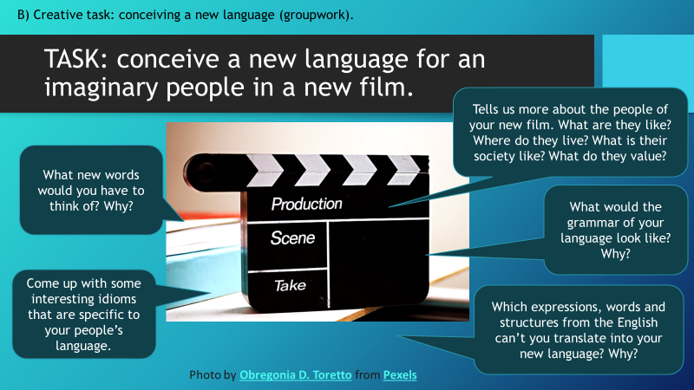

- Plenary TED ed talk: Artificial languages and dead languages issues (TED ed on artificial languages).

- Reflection (knowledge) question (can be explored in a TOK forum or as a written homework task, illustrated with real world examples)

In what ways do values affect our representations of the world, for example, in language, maps, or visual images?

Lesson 3: Language and power
(Lesson3_language_power_ppt; Lesson3_language_power_handout, Lesson3_appendix_1984, Language_glossary)
- Warm-up: thought experiment
Ask students the following questions (see linked powerpoint3):

- what might happen if we were never to use the word “good” anymore?
- What might happen if we had to remove all emotion from our language?
- What if we replaced all reference to “man” with “woman”?
- What if we banned any mention of the past (tense)?

- Creative and expressive learning activity: role play task (see linked powerpoint3). Assign pairs the following tasks:

- Try to declare your love without using emotive language, subjective language, ambiguous language, metaphors or comparisons.
- Try to protest a grave injustice brought on to you by your leader, but you must use euphemisms and cannot express any negativity.
- Try to explain the word “woman” to an alien without using any gendered (pro)nouns, referring to biological characteristics or societal constructs/gender norms.

- Brief analysis of 1984 passages: language, power and thought. (Possible link to English literature lessons, group 1 IBDP):
Lesson3_language_power_handout, Lesson3_appendix_1984

Ask who has read 1984. Many students will discuss the novel as part of their IBDP course, so it is likely at least one student has read it.
Ask students to share with the group what the novel is about. If necessary, provide a short synopsis yourself.
Explain that the dystopian system in 1984 aimed to control thought, partly by manipulating, censoring and altering language. The creative role-playing task (point 2 of this lesson) aimed to give students an experience of such “communication manipulation” and thought-control through language.

Then share out the short passages of 1984 (Appendix). Ask students to discuss in pairs what their passage seems to suggest regarding the relationship between language and power. Explore possible ways in which language can shape thought and how this manifests itself in the world around us.

- TED ed: What does Orwellian really mean?

Whole class activity. Show the talk to the class. Students note key concepts in TOK journal.
Afterwards, explore where we can see “Orwellian” use of language (and power) in the world around us.
Ask: Is it possible to control (or modify) thinking by controlling the use of language? Can you find real-world examples to illustrate this idea?
Ask: Who “owns” or “controls” the dominant way of speaking and thinking in our society?
Possible Follow-up: Introduction of concepts “dominant discourse” and “cognitive dissonance” (link to knowledge and politics).

- Summative exhibition practice (core teaching and learning activity of the lesson).
Students look for 1 object that tells us something about the relationship between language and power.
Use Lesson3_language_power_ppt; Lesson3_language_power_handout, for further guidance.
(If desired, adapt task and ask students to search for objects that illustrate the connection between language and knowledge in general.)

Example object:
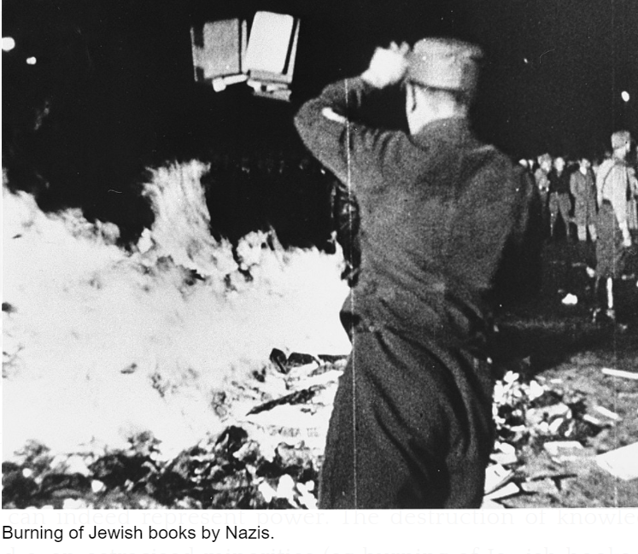

Ask students to create a mini-museum (or organize a “speed dating” activity), where students display the object on their laptops and communicate its relevance, real-world context and significance to others.
Encourage students to use (TOK) concepts they have learned during this unit, where possible. (Summative activity, see linked Language_glossary).

